Ex No: 14
Log Analysis for detection and response
Aim:
To analyze system and network logs to detect suspicious activities and respond to security incidents effectively in a SOC environment.
Procedure:
- Open a web browser and go to TryHackMe, then log in with your account.
- Search for the room related to Log Analysis for Detection and Response and open it.
- Read the introduction to understand the importance of log analysis in cybersecurity and incident response.
- Start the room by clicking “Start” or launch the machine if required.
- Study different types of logs such as system logs, network logs, authentication logs, and application logs.
- Analyze the provided log data to identify unusual or suspicious activities like failed login attempts, unauthorized access, or abnormal traffic.
- Use filtering, searching, and correlation techniques to find Indicators of Compromise (IoCs).
- Answer all the questions in each task based on your findings and verify the answers.
- Document key observations, tools used, and take screenshots if required for record submission.
- Complete all tasks until the room shows 100% completion.
- Log out from TryHackMe after finishing the experiment.

Task 1: Introduction
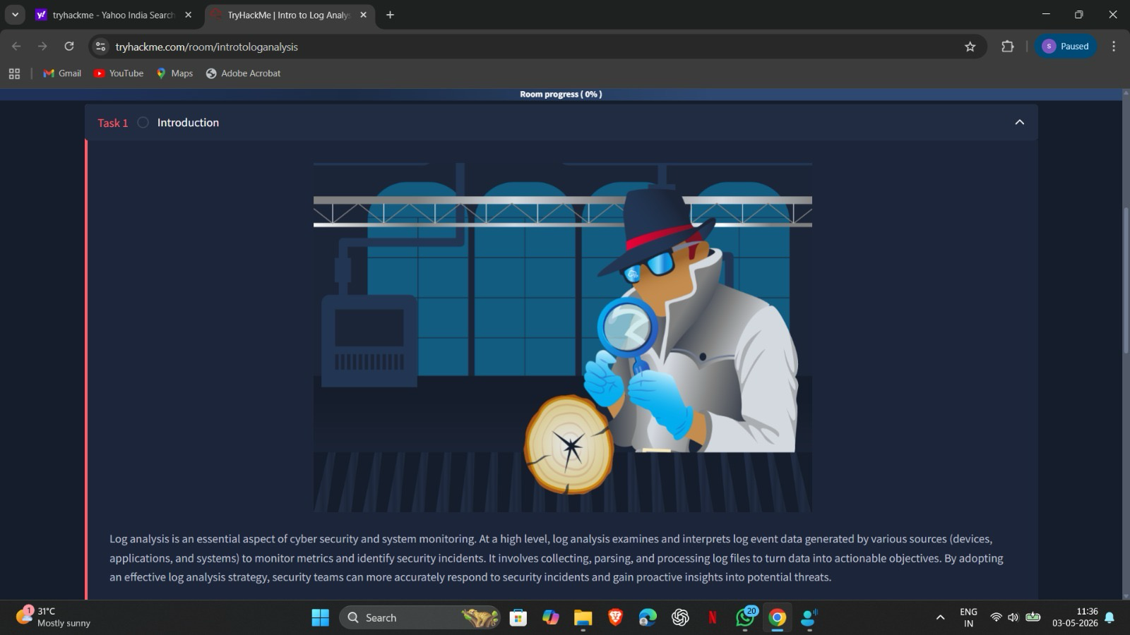

Task 2: Log analysis basics
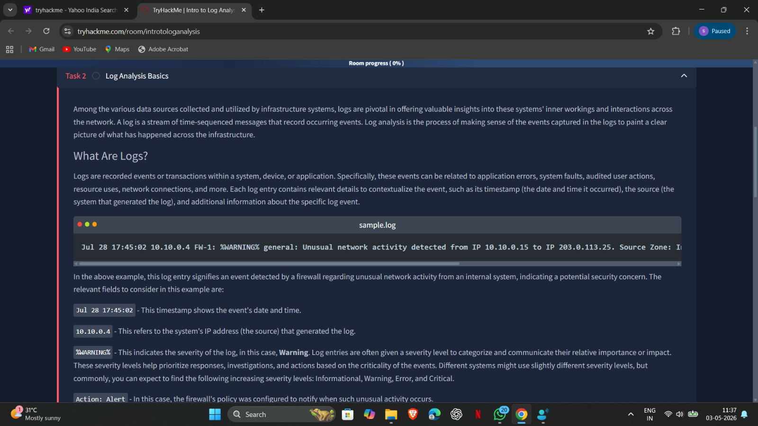
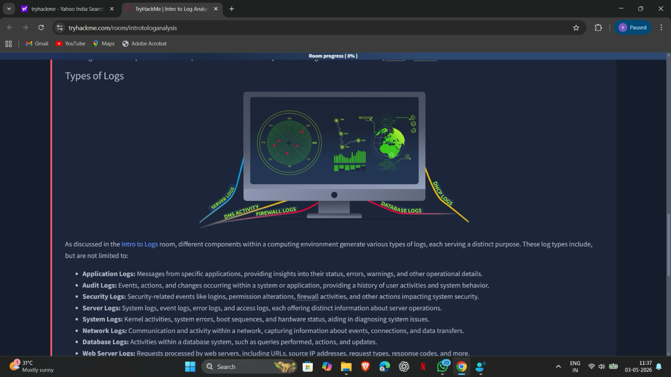

Task 3: Investigation theory
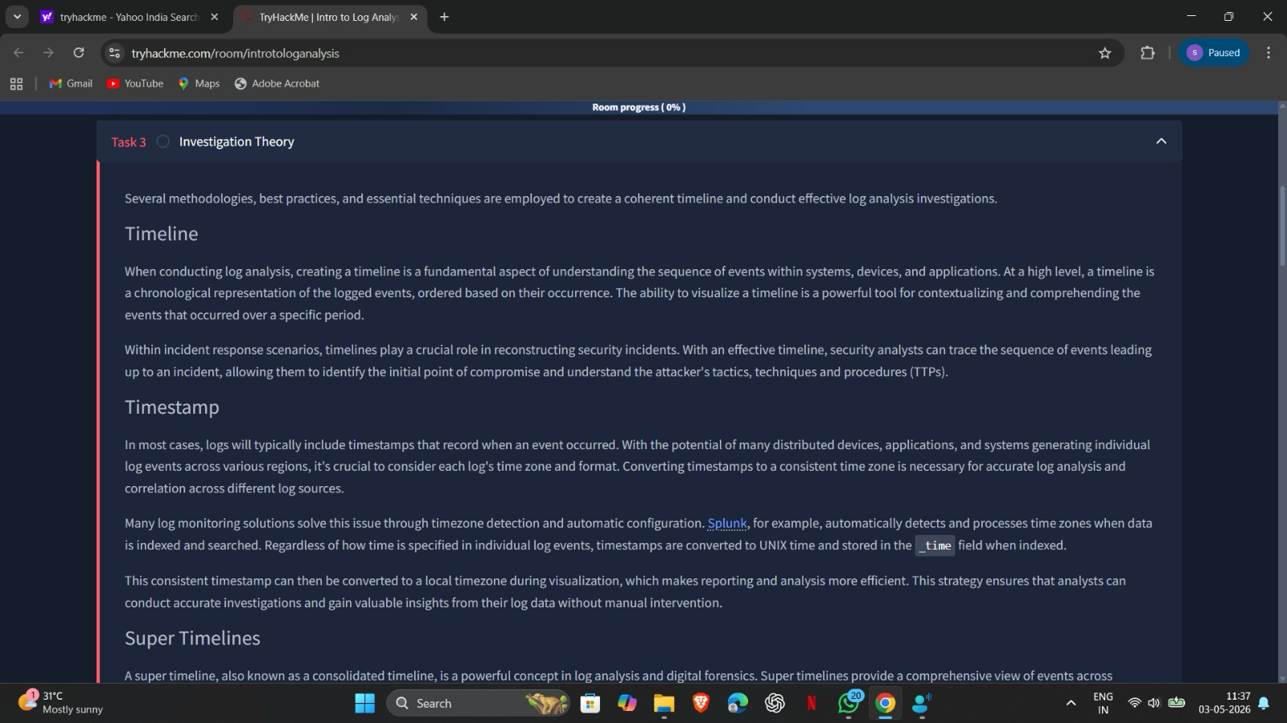

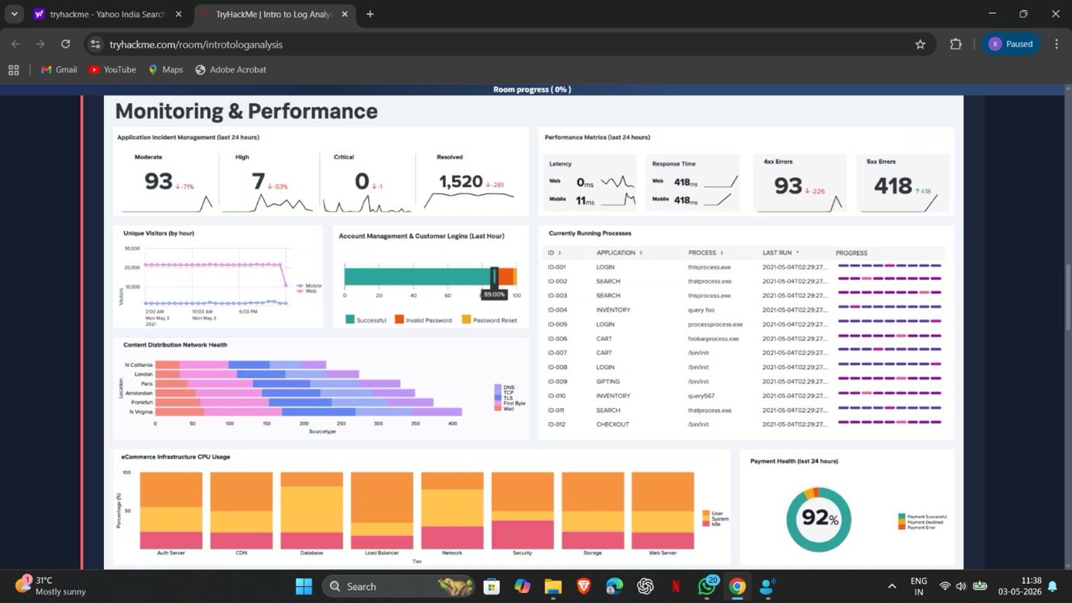

Task 4: Detection Engineering
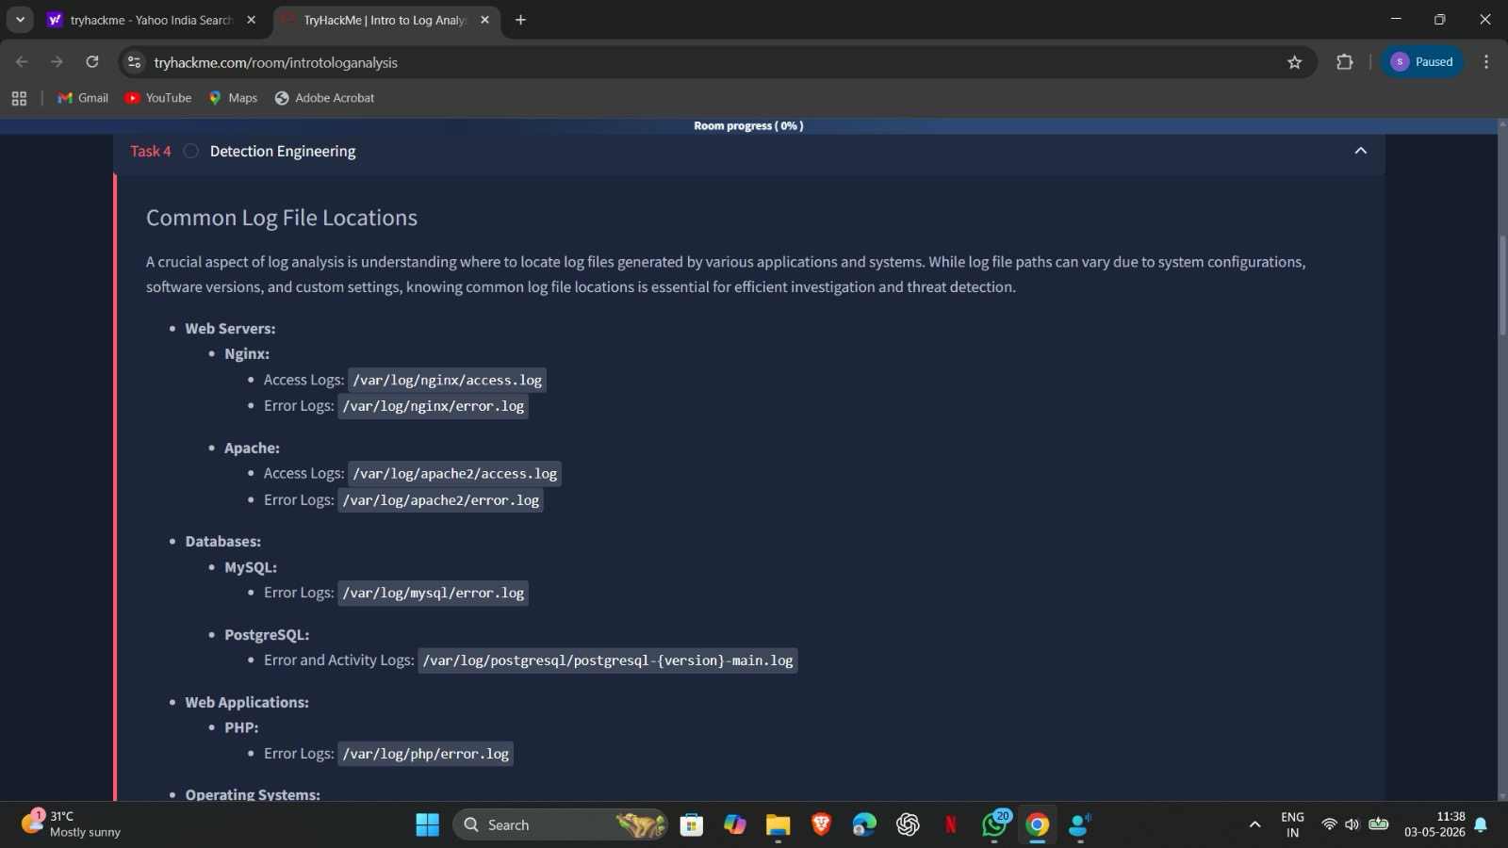
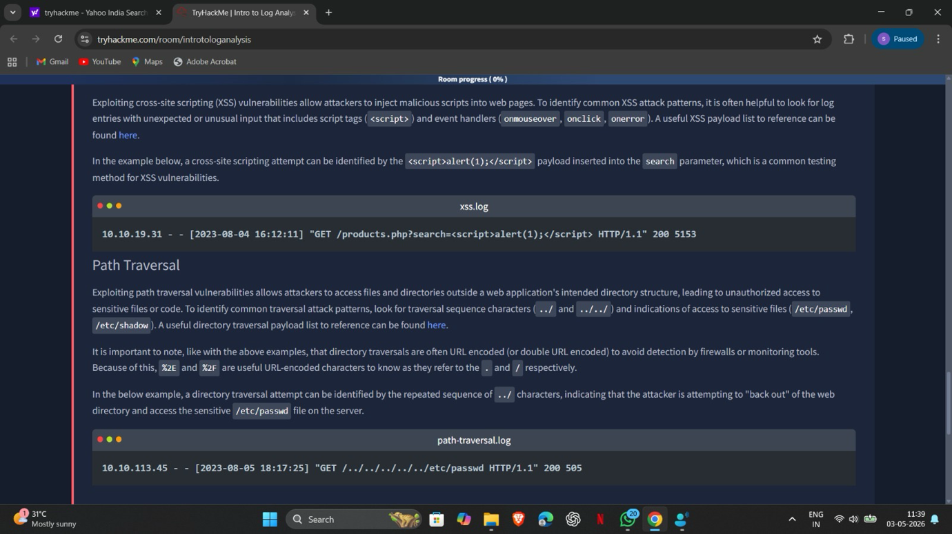

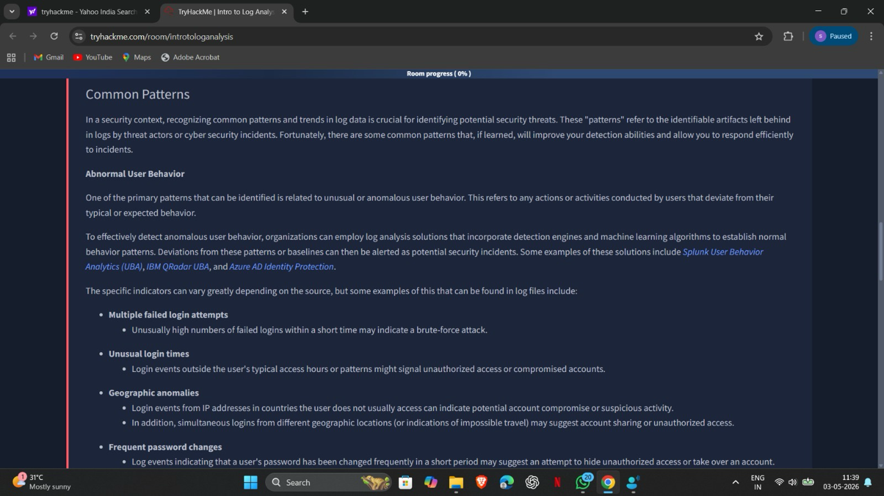
Task 5: Automatic vs Manual analysis
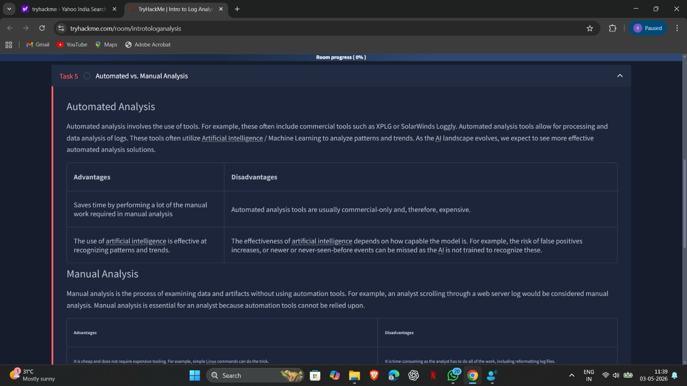

Task 6: Log analysis: Tool Command Line
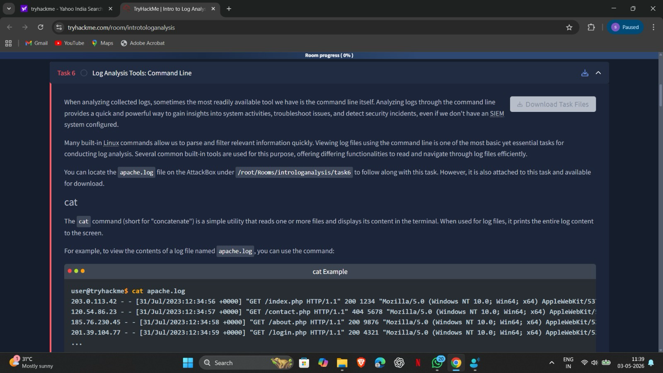
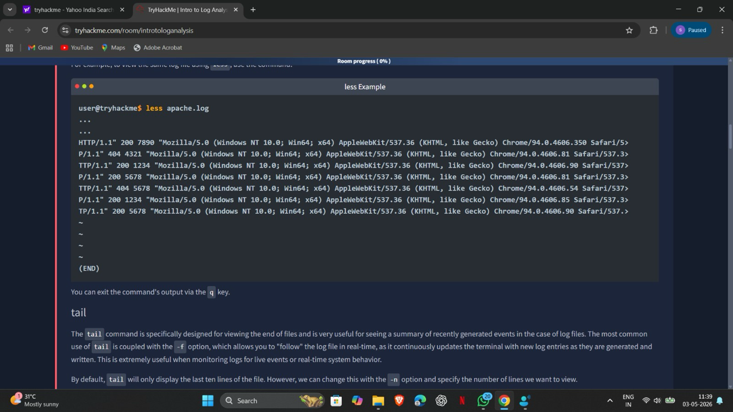

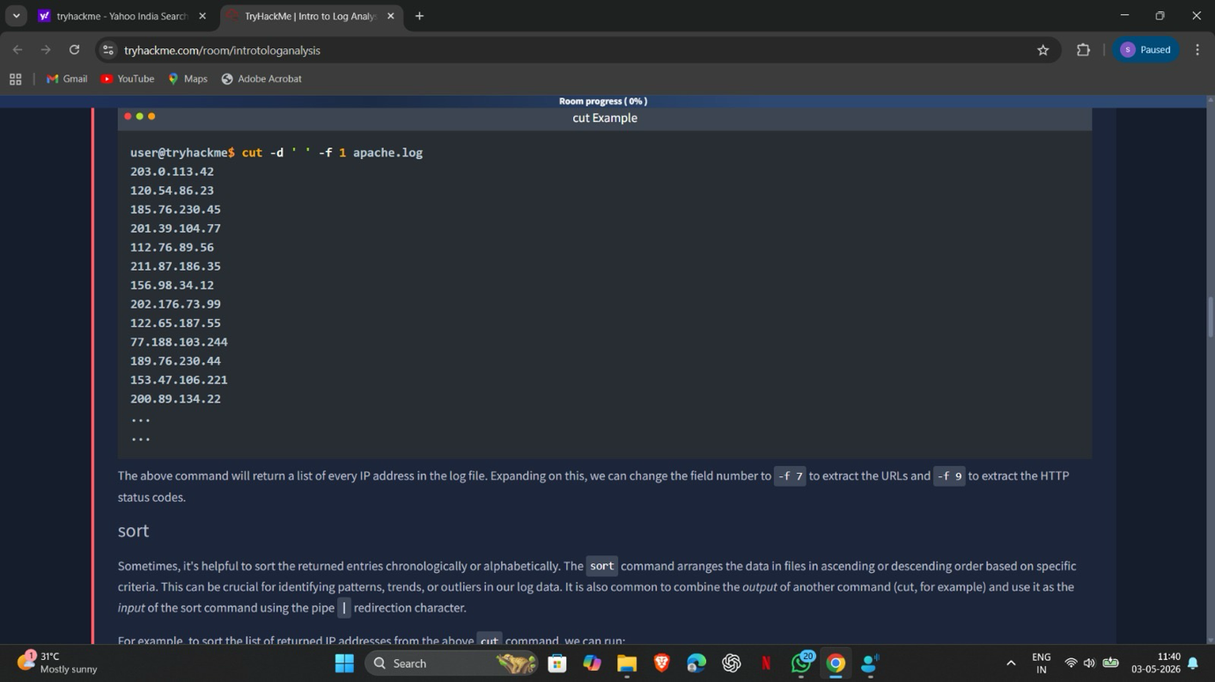

Task 7: Log Analysis Tool: Regular Expressions
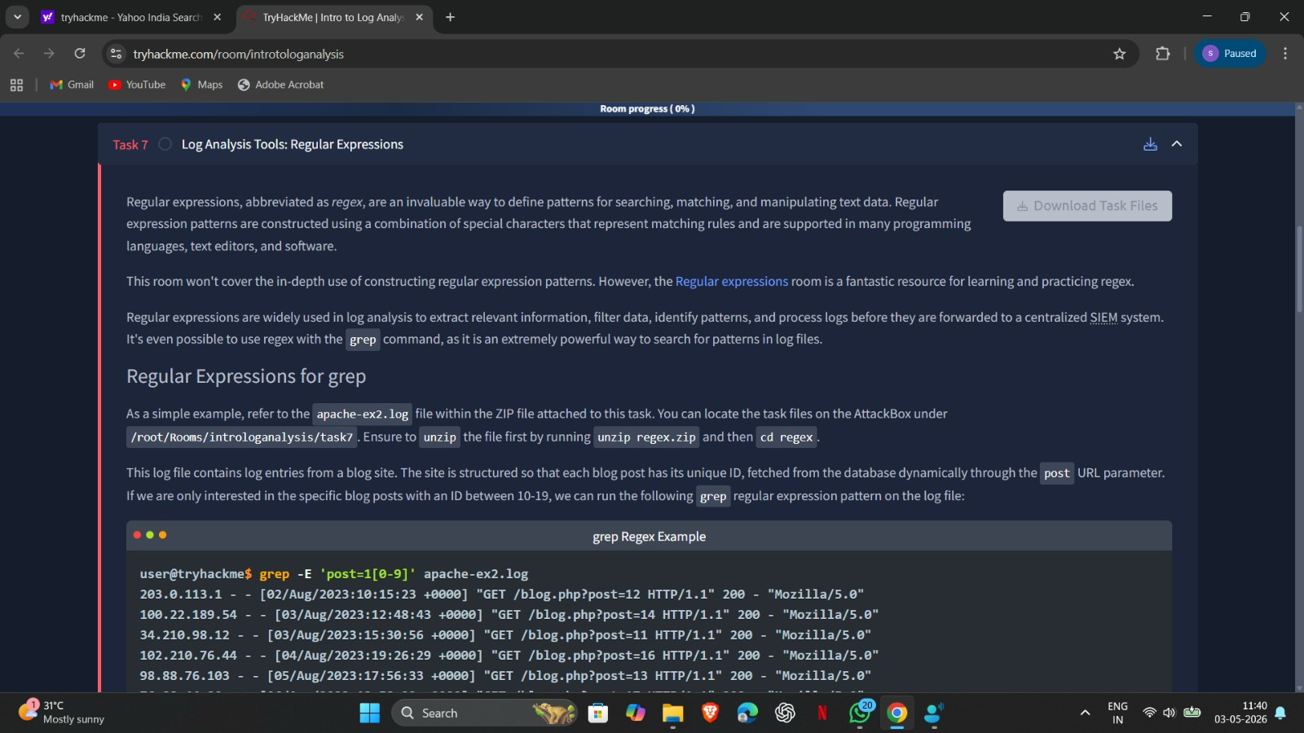
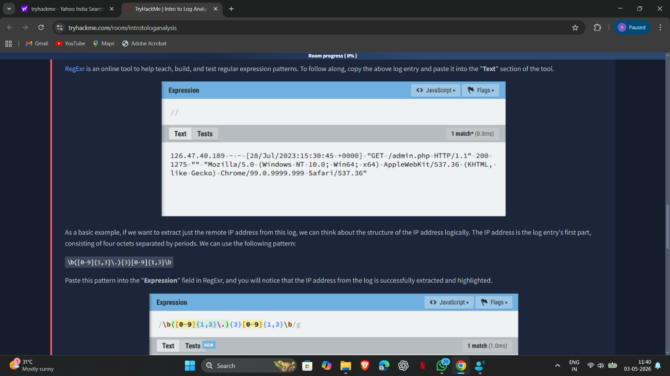

Task 8: Log Analysis Tool: CyberChef
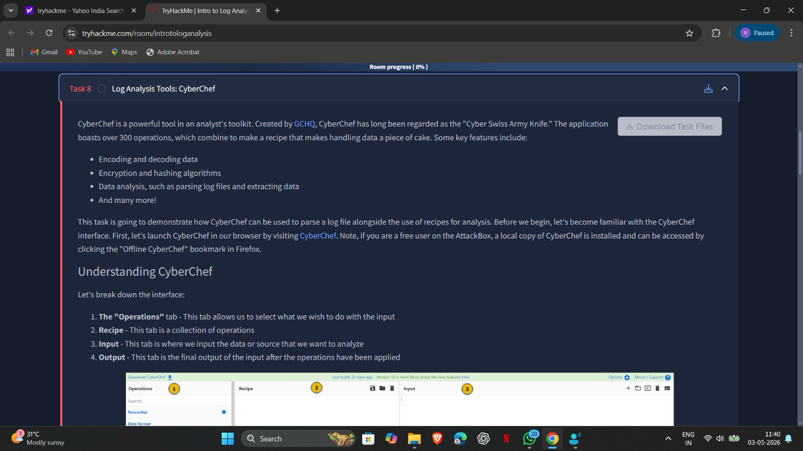



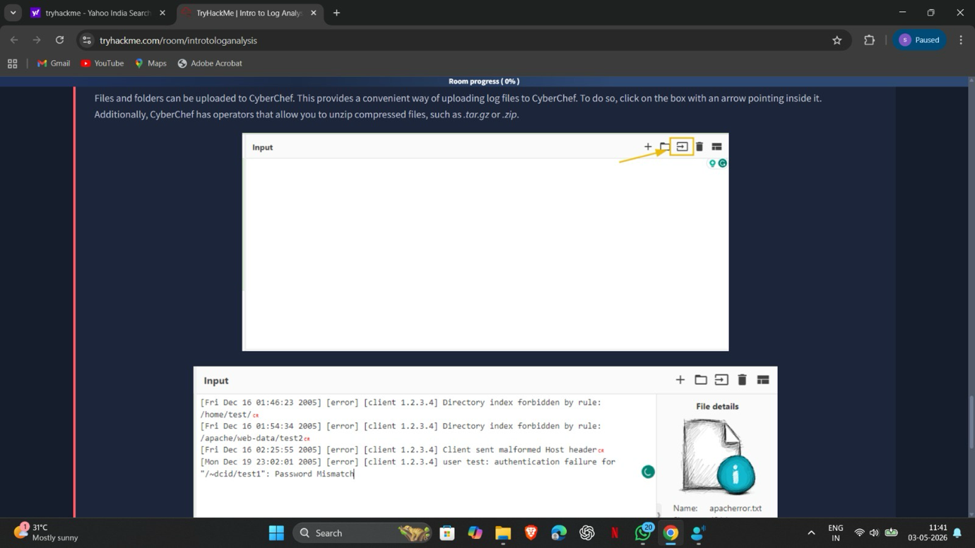

Task 9: Log Analysis Tool: Yara and Sigma
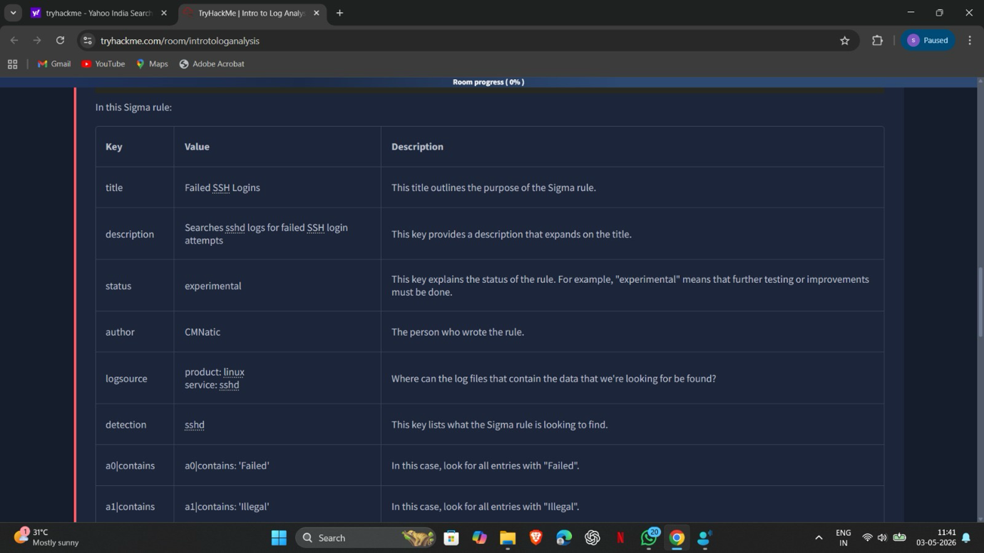

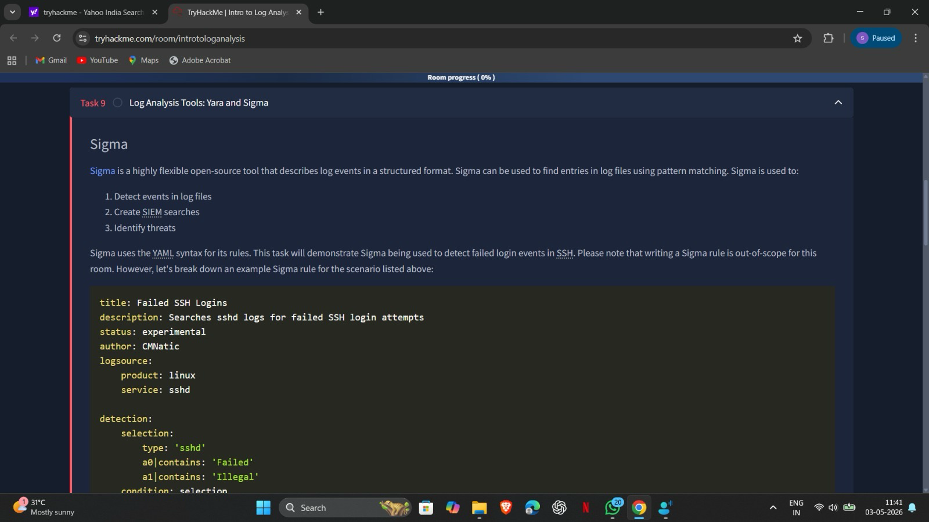

Result:
Successfully analyzed system and network logs to identify suspicious activities and potential security incidents. Gained practical knowledge in detecting Indicators of Compromise (IoCs) and responding to threats using log analysis techniques in a SOC environment.

